**EXCEL COLLEGE OF ENGINEERING(AUTONOMOUS)**

**NH-544, Salem Main Road, Sankari West, Pallakkapalayam, Pin:637 303. Komarapalayam Namakkal Dt. Tamilnadu.**

DEPARTMENT OF COMPUTER SCIENCE AND ENGINEERING.

WEB PHISHING DETECTION (**ASSIGNMENT 2)**

**DATE** : 06-11-2022

**PROBLEM :** PERFORM TASKS ACCORDINGLY **NAME** : Ningombam Chingkheinganba

**OUTPUT :**

**SCREENSHOTS:**

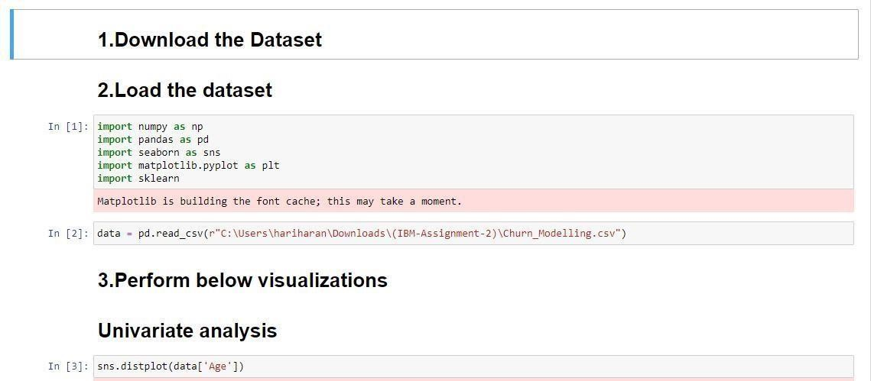

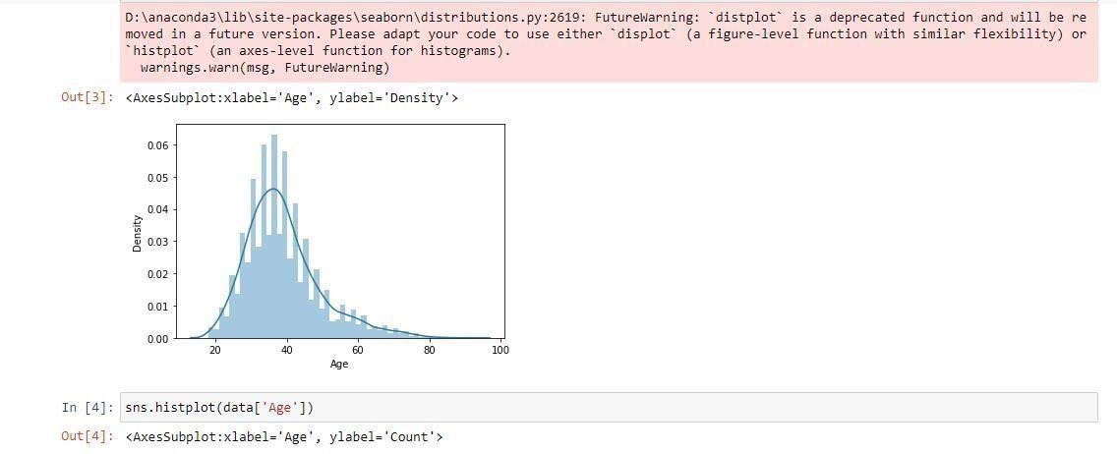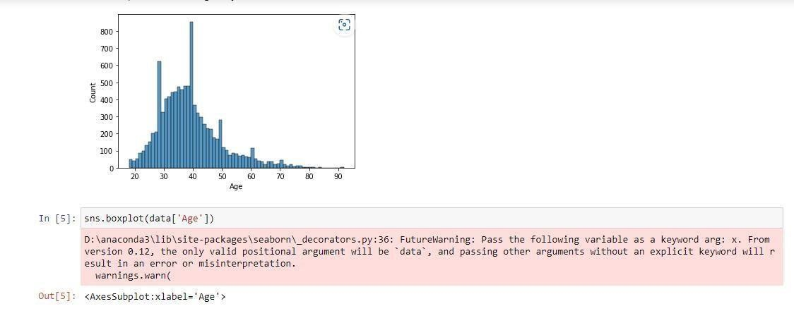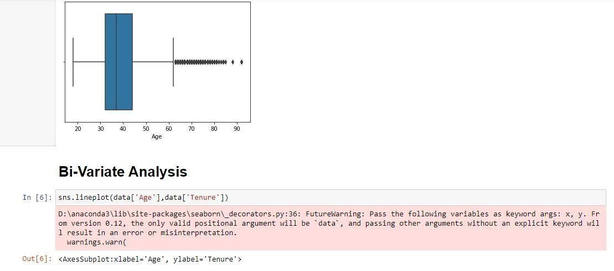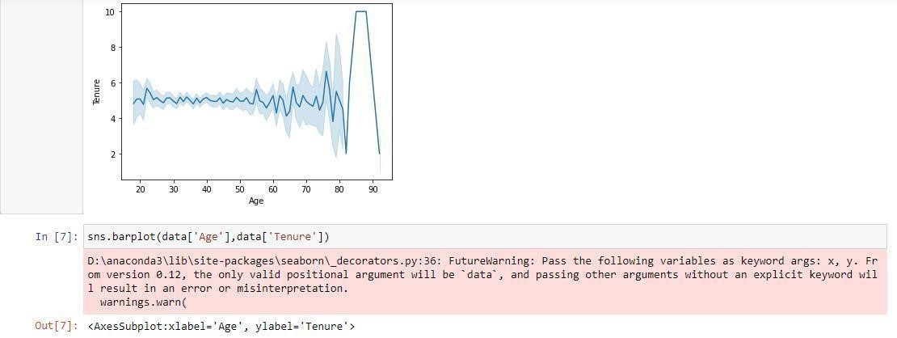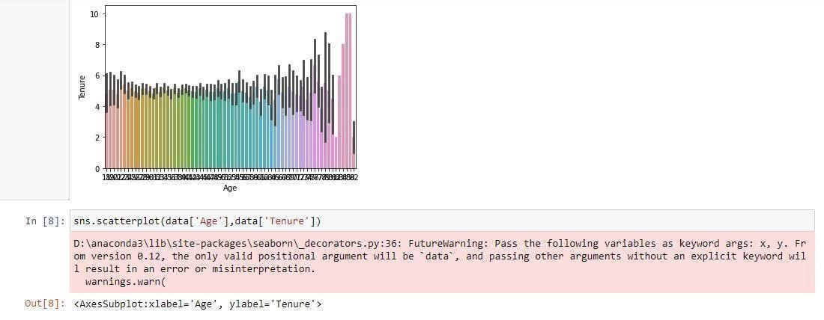

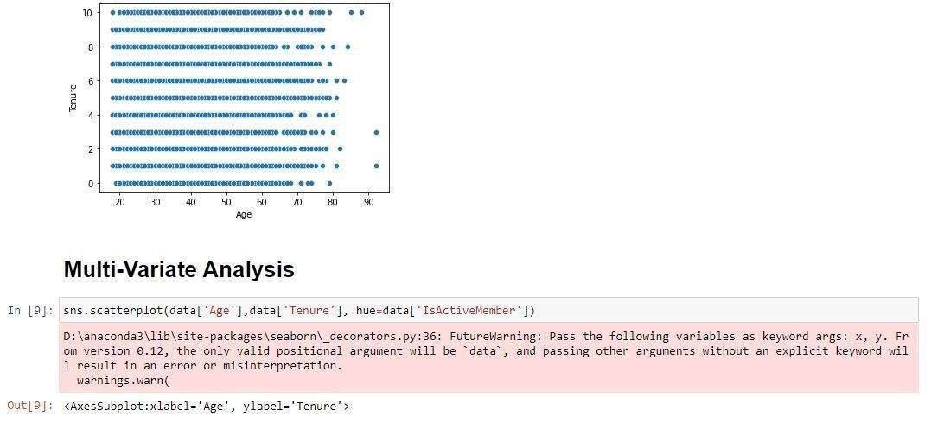

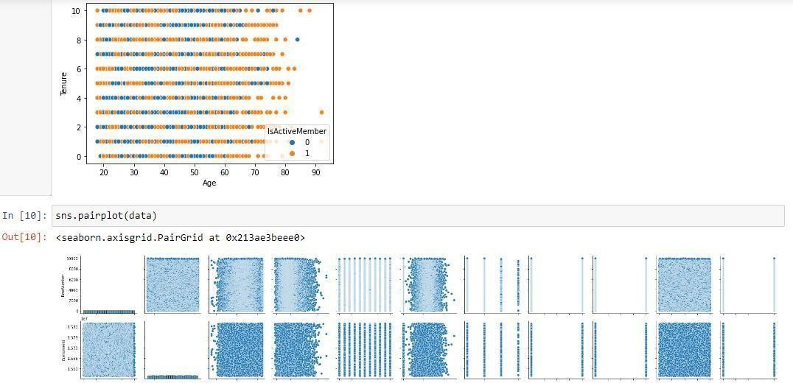

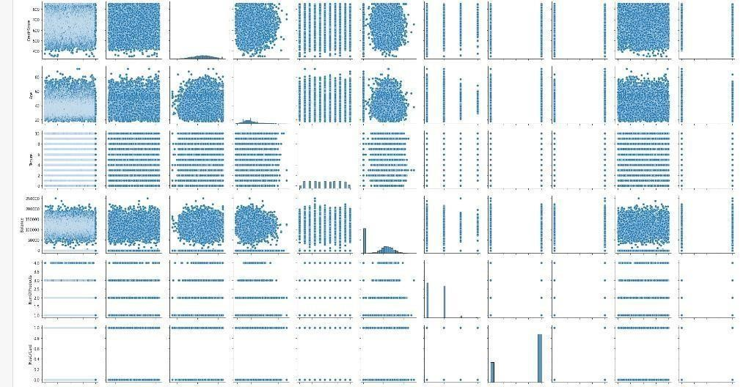

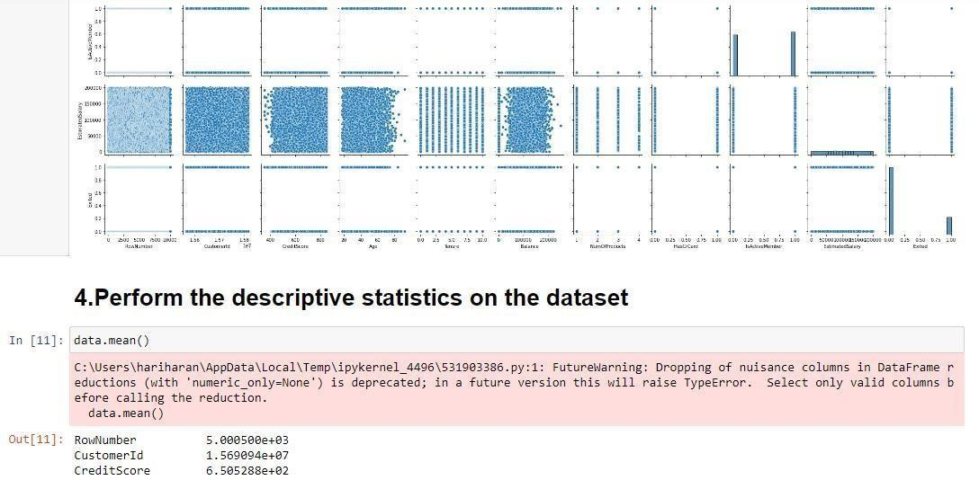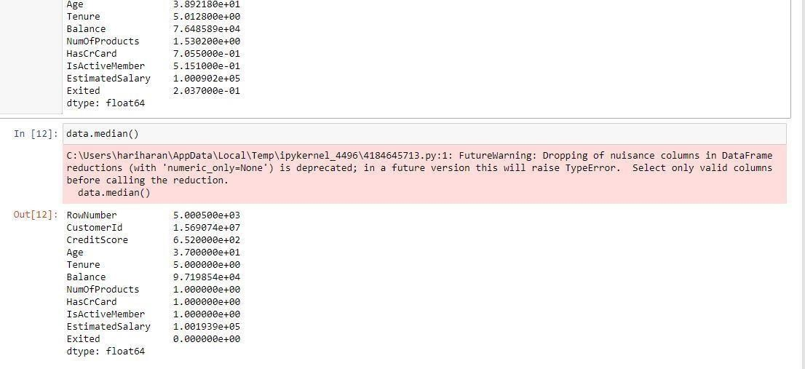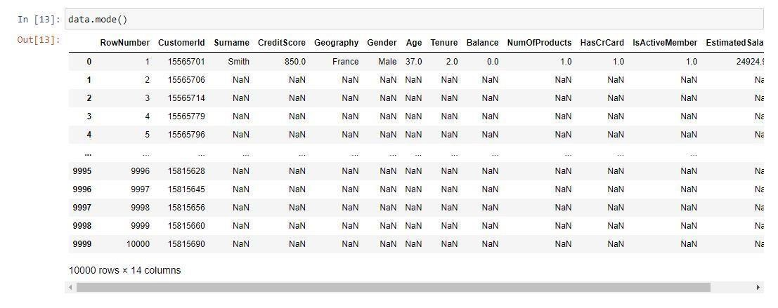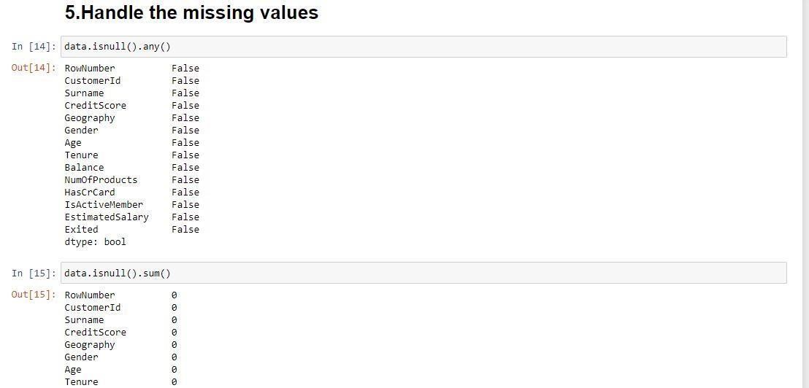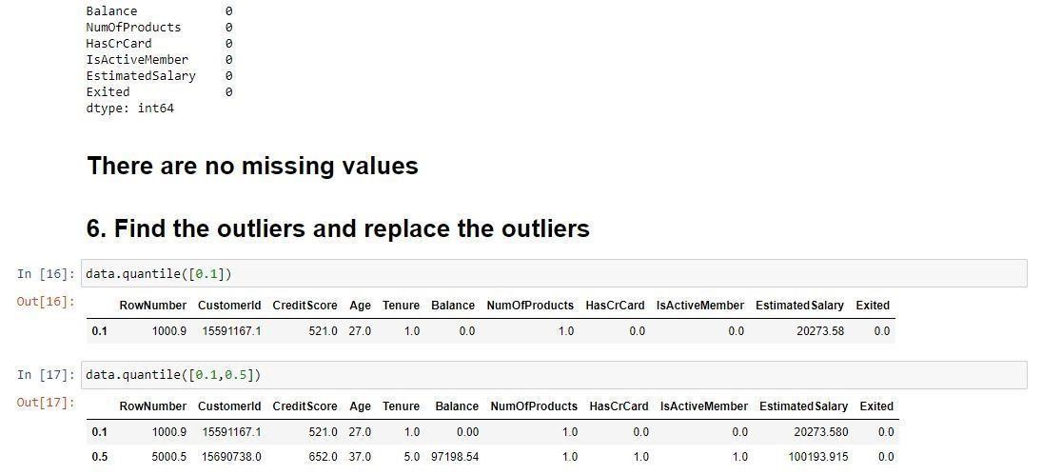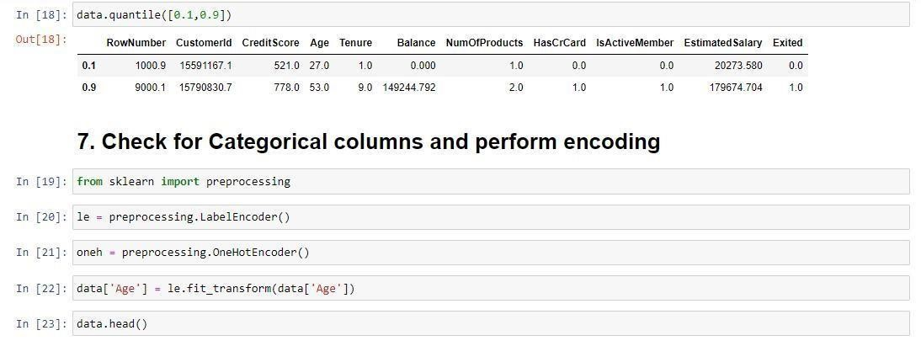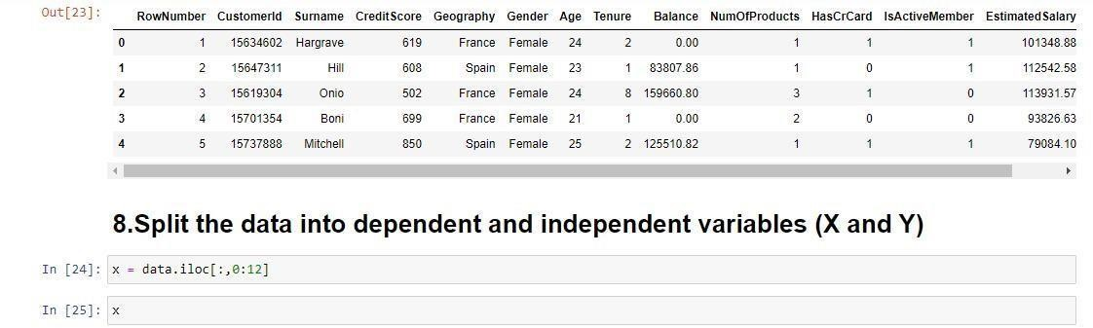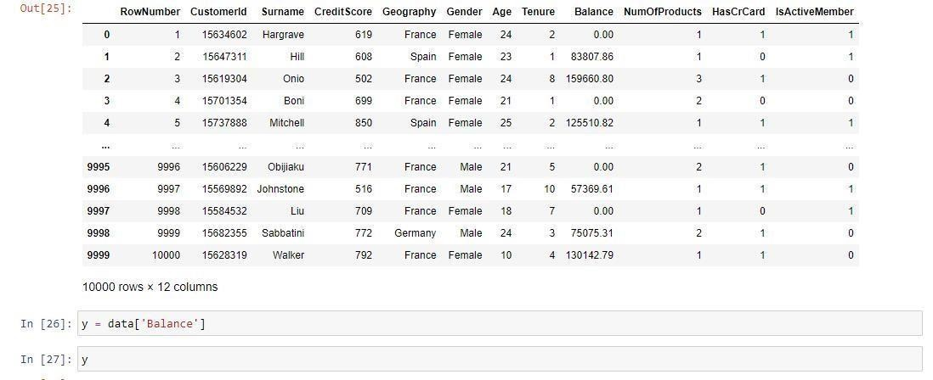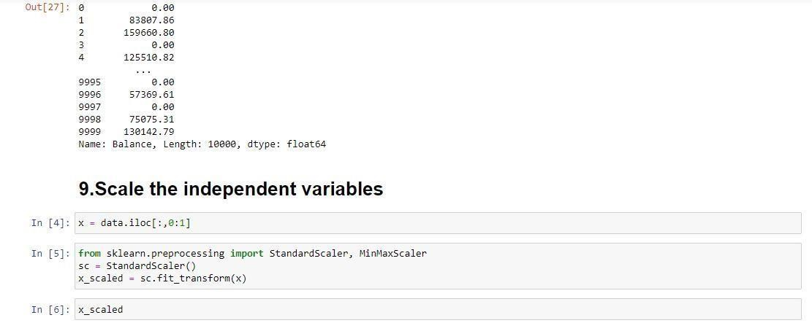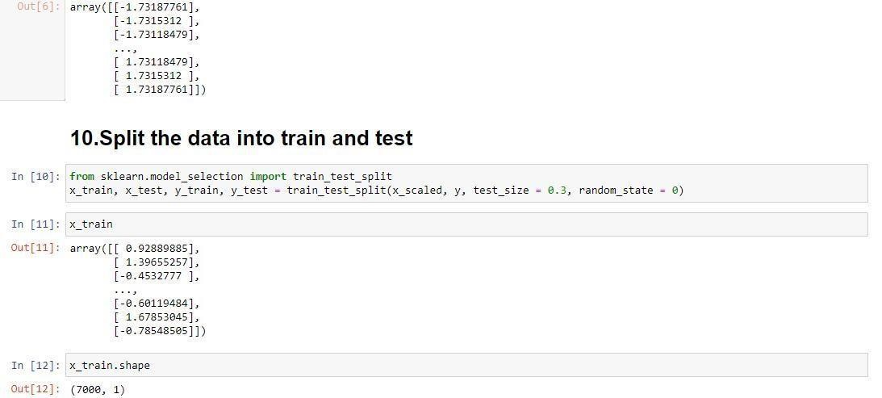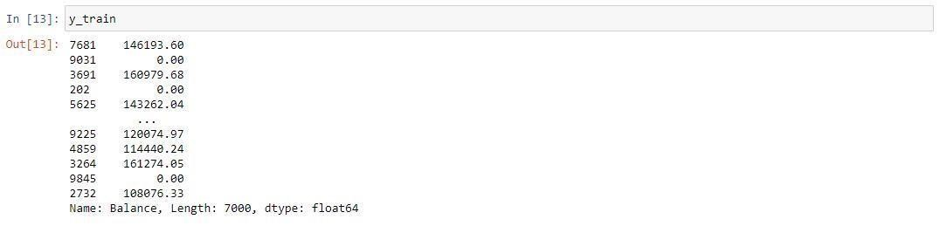

# ******************************THANKING YOU***********************************